Recent Strategies of Data compression in Wireless Sensor Networks

Dr. Shabana Mehfuz
Associate Professor, Electrical Engg. Department.
Jamia Millia Islamia
New Delhi,India
Senior Member, IEEE
mehfuz_shabana@yahoo.com

Usha Tiwari
Phd. Research Scholar, Elecrical Engg. Department
Jamia Millia Islamia
New Delhi,India
ushapant@rediffmail.com

Abstract— Wireless sensor networks (WSNs) constitute a continuously growing technology, taking advantage of new technology in electronic miniaturization that consume less energy for both processing and communication. Power consumption is the main issue that affects the lifetime of wireless sensor networks. A number of techniques are available to solve these issues. Among these techniques Data compression can be used to reduce the transmitted data over wireless channels. This leads to reduction in the required internodes communication, which is the main source of power consumer in wireless sensor networks. In this paper, a review of recent data compression techniques in wireless sensor network is provided. First a classification of existing techniques is presented to define the need of practical data compression in wireless sensor networks. Next details of techniques currently used by various technologists are taken into consideration. Finally their performance, open issues, limitations and suitable application are analyzed and compared based on the criteria given by practical data compression techniques in WSN’s.
Keywords—compression, sensors, energy consumption and nodes etc.

Introduction
A sensor network is an infrastructure composed of sensing , computing and communicating elements that gives a user the ability to instrument ,observe, and react to events and phenomena in specific environment. WSN’s are basically the collection of compact sized, relatively in expensive computational nodes that can be used to monitor the activities of a target and report events using radio communication to the sink node which is responsible for processing and sending the information via the internet.
Generally a sensor node consists of a three subunits: a sensing unit is used to acquire the target events or interesting data: a processing unit equipped with limited memory is used to manage the acquired data: and a communication unit, usually a radio receiver to exchange the information between nodes. Some of the research work shows that radio receiver is the main source of power consumption. The network processing schemes solves the power consumption issues by reducing the amount of data to be transmitted by means of aggregation techniques or Data Compression techniques.
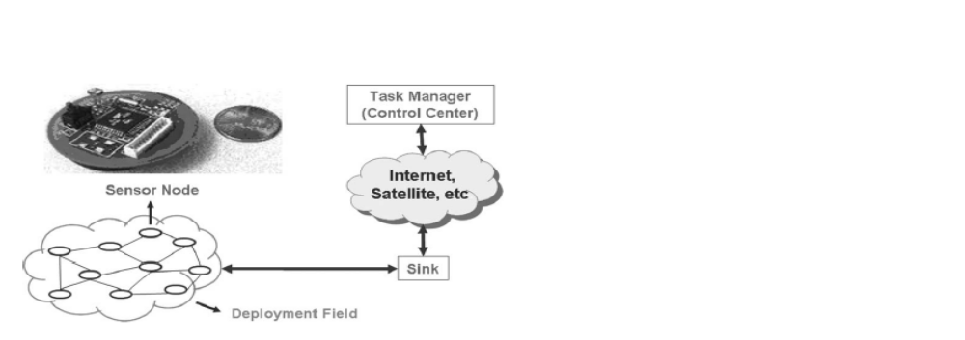
Fig1. An Illustrated Architecture of Wireless Sensor Network
Based on analysis, Data Compression algorithm can be classified into two categories: a distributed data compression approach and a local data compression approach as in Tossapom et al(2012)[1]. Since different applications have different data types, so a suitable data compression algorithm that can minimize the power consumption in particular areas should be considered.
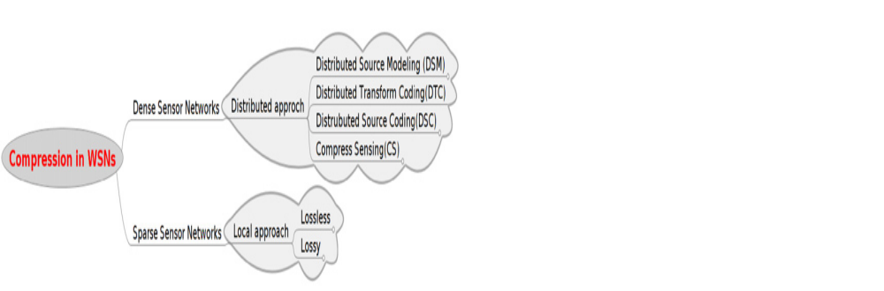
Fig2. Data Compression classification in WSNs

Data Compression Techniques in Wireless Sensor networks (WSN’s):
Data Compression is necessary for WSN applications, which have large amount of data to send across the network. Depending on importance of data type one may be better than the other. Data compression techniques involve reducing the size of information before transmission. Decompression of data occurs at base station. In compression it is important that no information is lost and individual readings are retained. In this section we represent the major Data compression Techniques proposed recently in last three or four years for WSN’s, and highlight the performance issues of each of the schemes.

Adaptive Compression:
Compression is a popular technique to reduce the data size by exploiting data redundancy, and can be used in delay sensitive wireless sensor networks (WSNs) to reduce end-to-end packet delay as it can reduce packet transmission time and contention on the wireless channel. However, the limited memory resources at sensor nodes make the processing time of compression a nontrivial factor in the total delay, and must be carefully examined when adopting compression scheme. In order to handle this issue, Xi Deng et al.(2012)[2] designed an Online Adaptive Compression Scheme in Delay Sensitive Wireless Sensor Networks, which is an adaptive algorithm to make online decisions such that compression is only performed when it can benefit the overall performance. They implemented the algorithm in a completely distributed manner that utilizes only local information of individual sensor nodes. Their experimental results show that the algorithm demonstrates good adaptiveness to network dynamics and maximizes compression benefit. They observe that compression does not always reduce the packet delay in WSN as generally known, but it is a joint result of both Network configuration and Hardware configuration.

In real time Image transmission, limited processing power, storage capacity, narrow bandwidth and required energy are the main issues to be considered. To address these concerns Mohsen Nasri et al.(2011)[3] introduces a Adaptive Image Compression scheme that ensures a significant computational and energy reduction as well as communication with minimal degradation of the image quality. This scheme is based on wavelet image transform and distributed image compression by sharing the processing of task to extend the overall lifetime of the sensor network. This technique is based on the fact that an individual node does not have sufficient processing power to completely compress a large volume of data to meet the particular requirements; this is not possible unless the node distributes the processing task among other nodes. For that a distributed method to share the processing task is necessary. This is based on a wavelet image transform called skipped high-pass sub-band (SHPS). This approach reduces the number of executed operations and therefore save the computation energy require during the wavelet image compression process.
The main cause of rapid drain of energy in multivariable wireless sensor network application is Radio communication between the different nodes and base station. Due the dynamic changes of environmental variables there is a need of an adaptive solution that cope up with these changes as time progresses. Murad A. Rassam et al(2013)[4] proposed a new adaptive and efficient dimension reduction model (APCADR) for sensor networks based on the candid covariance-free incremental PCA (CCIPCA). The performance of the model is evaluated using three real sensor networks datasets collected at Intel Berkeley Research Lab (IBRL), Great St. Bernard (GSB) area, and Lausanne Urban Canopy Experiments (LUCE).Results shows 33.33% and 50% reduction of multivariate data in dynamic and static environment. Results also show that 97–99% of original data is successfully approximated at cluster heads in both types of environment. A comparison with the multivariate linear regression model (MLR) and simple linear regression model (SLR) shows the advantage of the given model in terms of approximation accuracy, efficiency and adaptability with dynamic environmental changes.

Loss less compression algorithms:
Energy is a primary constraint in design and deployment of WSN, energy efficiency can be achieved by reducing radio communication limiting transmission and reception of data. Francesco Marcelloni et al(2009)[5]. proposed a Lossless entropy compression (LEC) algorithm which can be implemented in a few lines of code, requires very low computational power, compression data uses very small dictionary whose size is determined by the resolution of A-D converter. In this, they have tested the effectiveness of algorithm by compressing four Temperature and humidity data sets collected by real WSNs, and solar radiations, seismic and ECG data sets. They have obtained compression ratio up to 70.81% & 62.08% for above listed data sets and of the order of 70% for other data sets.

Lossy compression Techniques:

Francesco Marcelloni et al.(2010)[6], proposed an approach to perform lossy compression on single node based on a differential pulse code modulation (DPCM) scheme with quantization of the differences between consecutive samples. As the different quantization process has different compression performance and information loss, so they have introduced a multi-objective evolutionary algorithm to generate a set of combinations of these parameters corresponding to different optimal trade-offs. For showing the effectiveness of the designed lossy algorithm they have tested it against some real-world temperature datasets. In particular, they used temperature measurements from three Sensor Scope deployments [38]: Fish Net Deployment, Grand-St-Bernard Deployment and Le Gènèpi Deployment. They have achieved a high compression ratio at High Signal to Noise ratio.
C.Duran-Faundez etal.(2011)[7] proposed a light weight image compression algorithm called TiBs(tiny block-size image compression), explicitly designed for resource-constrained camera devices. TiBS basically operates on independent blocks of 2x2 pixels. The compression algorithm is based on pixel removal (also referred as pixel sub sampling) in a self-adaptive manner. Pixel removal involves here removal one pixel per block, which therefore provides a compression ratio of 4:3.TiBS also includes a scalar quantizer and a variable-length coding so as to achieve the higher compression ratios. In another process TiBS is combined with a pixel interleaving scheme (also referred as pixel mixing) to improve the robustness of image communication under packet losses conditions. The mixing scheme is based on torus automorphisms and they have proposed some adaptations to the initial method in order to minimize memory cost and latency, and hence energy cost. The result shows that TiBS is able to achieve compression ratios between 2.5 and 3.5 at medium quality setting. This gives 60% reduction of the energy as compared to the uncompressed images.

Compression Algorithms for increasing Networks Life Time :
Extending the lifetime during which a WSN can cover all targets is a key issue in WSN applications such as surveillance. Chuan-Kang Ting etal.(2010)[8] proposed a memetic algorithm to solve these kind of problem. The memetic algorithm implements the Darwinian evolutionary scheme and Lamarckian local enhancement to search for optimal solution.The proposed algorithm does not require an upper bound or any assumption about the maximum number of covers. The results of variety of problems confirm that the algorithm significantly outperforms several heuristic and evolutionary algorithms in terms of quality solution, which demonstrate the effectiveness of the proposed algorithm in extending WSN lifetime. The MA implements the GA scheme and additionally adopts the compact operator, which is a local enhancement operator that is designed specifically for the SET K-COVER problem.
In a similar way, Guimin Huang etal.(2013)[9] proposed a new data processing algorithm based on B-spline fitting model, called as BFM algorithm. The BFM algorithm can compress data effectively, and thus reduces the amount of data to be transmitted. This algorithm saves the energy consumption of WSNs and prolongs the lifetime of WSNs. Through a series of experiments, the BFM algorithm is compared with the Tiny DB model. The results show that BFM algorithm outperforms the Tiny DB model in terms of data transfer ratio. The BFM algorithm condenses the monitoring data collected from nodes of sensor network. By using BFM algorithm, the energy consumption can be reduced, which results in increasing the network lifetime.
A recursive smoothing method is adopted by C. Hua, T.-S. Peter Yum etal(2008)[10] to overcome the non-differentiability of the objective function. They have derived necessary and sufficient conditions for achieving the optimality of the optimization problem and design a distributed gradient algorithm according to that. Numbers of simulations are carried out to show that the proposed algorithm can significantly reduce the data traffic and improve the network lifetime. The convergence of the algorithm is studied for various network configurations.

Some other Recent Techniques of Compression:
In more recent work Amar etal.(2010)[11], the authors consider the data fusion problem in which each sensor node observes part of a data vector. Then, each data vector is compressed or encoded by means of KLT. Once those encoding matrices are sent to the fusion center, it reconstructs the entire data vector from these compressed sensor observations with minimal MSE. The greedy algorithm is performed on the fusion center or sink node, where it does not have power constraints. In each step, one of the encoding matrices is selected and updated by appending an additional row. The principle of selecting a sensor node is based on the MSE of reconstructed data vector comparing to second-order statistics of observation known to the fusion center. Based on the simulation results of Amar etal.(2010), the greedy algorithm performed equally well in terms of MSE when compared to the local KLT algorithm.

Y.P. Hu et al.(2011)[12] proposed a so-called CCS-MAC (collaborative compression strategy-based MAC) MAC protocol, which facilitates to exploit those overheard data that is treated useless in traditional MAC protocols for the purpose of cost and energy savings. CCS-MAC enables different sensor nodes to perform data compression cooperatively with regard to those overheard data, so that the redundancy of the data prepared for the link layer transmission can be totally eliminated at the earliest. The node-selection algorithm is implemented in CCS-MAC at each sensor node in a distributed manner. The result verifies that the proposed CCS-MAC scheme can achieve a significant energy savings to increase the lifetime of a Sensor Network.

In the traditional clustering structure, when the node equipped with camera or the cluster head compresses the images, an energy hole will appear. This is a main factor that affects the lifetime of a sensor network. To avoid the energy hole problem, Z. Zuo et al.(2012)[13] proposed a two-hop clustered image transmission scheme. In the given scheme, many redirectors are used to compress and forward the images for the purpose of reducing energy consumption of the node equipped with camera and camera clusters. With adaptive adjustment of the transmission radius in the camera cluster and tasks allocation based on the residual energy of the normal sensor nodes by the camera-equipped node, the energy consumed by the nodes in the network is balanced. If the sensor nodes are deployed densely, proposed scheme will result in increasing the lifetime of sensor network.
Systems mapped on CMOS architectures are often expected to achieve high processing bandwidth and low energy consumption. But a specific care should be taken to create a balance between algorithm structure and circuit architecture, when designing multimedia wireless embedded networking systems. So, M.L. Kaddachi etal(2012)[14] addresses the problem of low power consumption and real time constraints for image communication in wireless camera sensor networks (WCSN). It gives a low complexity hardware Implementation of JPEG like encoder for image compression and paquetization. The circuit to be designed is embedded in the camera sensor node to relieve the main processor from the data processing tasks. This encoder combines the best lifting DCT algorithm available in the literature with a zonal coding approach. The first one reduces the number of operations required per DCT coefficient while the latter reduces the number of coefficients to be computed, quantized and encoded.

conclusion and future work
In this article, we surveyed the recent data compression approaches introduced in past few years for Wireless Sensor Networks. We reviewed and analyzed these approaches based on the requirements which we observed from real world applications. Based on our observation it is clear that local approaches are better than as compared to distributed approaches as local approaches do not exploit any benefits of network routing and topology. But these kinds of approaches do not give good result when nodes are densely distributed. This paper summarizes details, performance, suitable applications, and limitations of recently developed schemes in Wireless Sensor Networks. The surveyed results in this work will serve as a useful guideline for designing new practical data Compression algorithms for wireless sensor networks. None of the strategies presented in the paper address multiple data types and therefore this still remains an open area for future research.

References
- Tossaporn, Srisooksai, Kamol Keamarungsi, Poonlap Lamsrichan , Kiyomichi Araki, Practical Data Compression in wireless sensor networks: A Survey in Journal of Network and Computer Applications, Elsevier Science Direct vol. 35(2012) page 37-59.
- Xi Deng, Yuanyuan Yang “Online Adaptive Compression in Delay Sensitive Wireless Sensor Networks” in IEEE Transactions on computers, Oct. 2012 (vol. 61 no. 10) pp. 1429-1442.
- Mohsen Nasri, Abdelhamid Helali, Halim Sghaier, Hassen Maaref “Adaptive image compression technique for wireless sensor networks” in Computers and Electrical Engineering, Elsevier Science Direct,37 (2011),Pg. 798–810.
- Murad A. Rassam∗, Anazida Zainal, Mohd Aizaini Maarof “An adaptive and efficient dimension reduction model for multivariate wireless sensor networks applications” in journal of Applied Soft Computing, Elsevier Science Direct, 13 (2013) Pg1978–1996.
- Francesco Marcelloni , Massimo Vecchio “An Efficient Lossless Compression Algorithm for Tiny Nodes of Monitoring Wireless Sensor Networks” in The Computer Journal Advance Acess” ,British Computer Society,2009.
- Francesco Marcelloni , Massimo Vecchio “Enabling energy-efficient and lossy-aware data compression in wireless sensor networks by multi-objective evolutionary optimization” in journal of Information Sciences, Elsevier Science Direct 180 (2010) Pg.1924–1941.
- Cristian Duran-Faundez,Vincent Lecuire, FrancisLepage “Tiny block-size coding for energy-efficient image compression and communication in wireless camera sensor networks” in Signal Processing: Image Communication, Elsevier Science Direct, 26 (2011)466–481 .
- Chuan-Kang Ting ⇑, Chien-Chih Liao “Memeti algorithm for extending wireless sensor network lifetime” in Information Sciences, Elsevier Science Direct 180 (2010) 4818–4833.
- Guimin Huang a, Yuanyuan Chena, Ya Zhoua, Pingshan Liua, Siyun Liua “A New Data Processing Algorithm Based on Model Fitting for
Wireless Sensor Networks” in a Procedia Computer Science 17 ( 2013 )
1154 – 1161. Published by Elsevier B.V. Selection and peer revie under
responsibility of the organizers of the 2013 Internation Conference on
Information Technology and Quantitative Management.
- Cunqing Hua,Tak-Shing Peter Yum “Data aggregated maximum lifetime routing for wirless sensor networks” in Ad Hoc Networks, Elsevier Science direct, 6 (2008) 380–392.
- Amar A,LeshemA,GastparM. “Recursive implementation of the distributed Karhunen–Loeve transform”. In Trans Signal Process,Elsevier Science Direct, 2010;58: 5320–30.
- Y. Peng Hu, R. Li ⇑, S. Wang Zhou, Y. Ping Lin “CCS-MAC:Exploiting the overhead data for compression in wireless sensor networks” Computer Communications, Elsevier Science Direct 34 (2011) 1696–1707
- Zhen Zuo, Qin Lu , Wusheng Luo “ A two–hope clustered image transmission scheme for maximising network lifetime in wireless multimedia sensor network” in Computer Communications Networks, Elsevier Science Direct , 35 (2012) 100–108.
- Med Lassaad Kaddachi a,n, Adel Soudani a, Vincent Lecuire b,c, Leila Makkaoui b,c, Jean-Marie Moureaux b,c, Kholdoun Torki “Design and performance analysis of a zonal DCT-based image encoder for Wireless Camera Sensor Networks” in Microelectronics Journal,Elsevier Science Direct, 43 (2012) 809–817

